**Quiz 4/12**

**Q)**

**Find one commercial example of a smart contract and explain it.**

**A)**

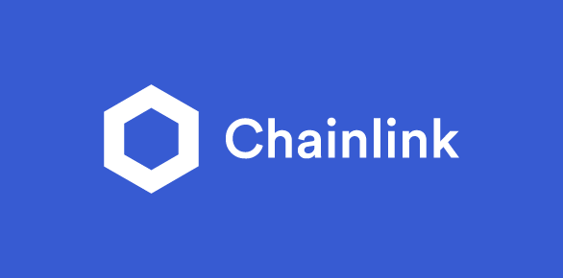

* **Chainlink** is a decentralized blockchain oracle network built on Ethereum.
* It enables smart contracts to have secure access to off-chain data.
* Chainlink ensures reliability, security, and scalability.
* It uses cryptography techniques like multi-party computation.
* Chainlink supports a wide range of data sources, including APIs and IoT devices.
* Chainlink's token, LINK, is used as a utility token.
* It has the potential to be a critical infrastructure layer in the blockchain ecosystem.